1.000 IN. DIAMETER - 0.250 IN. LEAD
This 1 inch diameter ball screw has a 0.250 inch lead. Corresponding ball nuts are available in standard capacity, high capacity, and ultra-high capacity..
BALL SCREW SPECIFICATIONS | RH | LH
BALL SCREW PART NO. | BS 100 R 025 A | BS 100 L 025 A
NOMINAL BALL CIRCLE DIAMETER | 1.000 IN.
LEAD | 0.250 IN.
SCREW DIAMETER | 0.980 IN.
ROOT DIAMETER | 0.840 IN.
SCREW WEIGHT | 2.18 LB./FT.
TORQUE TO RAISE 1 POUND* | 0.044 IN.-LB.
MAXIMUM SCREW LENGTH | 12 FT.
* Torque to raise 1 pound = 0.177 x inches lead x pounds load

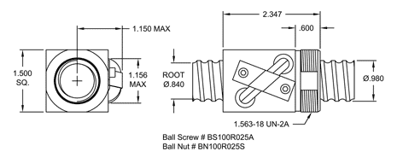
Standard Capacity Ball Nut Specifications (S)
BALL NUT SPECIFICATIONS | RH | LH
BALL NUT PART NO. (STANDARD CAPACITY) | BN 100 R 025 S | BN 100 L 025 S
BALL NUT WITH FLANGE PART NO. | BF 100 R 025 S | BF 100 L 025 S
DYNAMIC LOAD CAPACITY** | 1,625 LB.
STATIC LOAD CAPACITY | 13,000 LB.
BALL NUT WEIGHT | 0.83 LB.
NOMINAL BALL DIA. (AVG. BALL QTY.) | 5/32 IN. (85)
FLANGE PART NO. | FL-1563
WIPER KIT PART NO. | WK-40

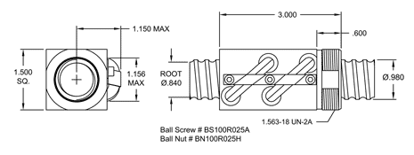
High Capacity Ball Nut Specifications (H)
BALL NUT SPECIFICATIONS | RH
BALL NUT PART NO. HIGH CAPACITY) | BN 100 R 025 H
BALL NUT WITH FLANGE PART NO. | BF 100 L 025 H
DYNAMIC LOAD CAPACITY** | 3,250 LB.
STATIC LOAD CAPACITY | 26,000 LB.
BALL NUT WEIGHT | 1.12 LB.
NOMINAL BALL DIA. (AVG. BALL QTY.) | 5/32 IN. (170)
FLANGE PART NO. | FL-1563
WIPER KIT PART NO. | WK-40

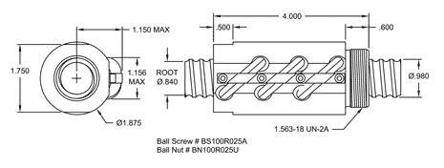
Ultra High Capacity Ball Nut Specifications (U)
ALL NUT SPECIFICATIONS | RH
BALL NUT PART NO. HIGH CAPACITY) | BN 100 R 025 U
BALL NUT WITH FLANGE PART NO. | BF 100 L 025 U
DYNAMIC LOAD CAPACITY** | 4,500 LB.
STATIC LOAD CAPACITY | 39,000 LB.
BALL NUT WEIGHT | 1.92 LB.
NOMINAL BALL DIA. (AVG. BALL QTY.) | 5/32 IN. (255)
FLANGE PART NO. | FL-1563
WIPER KIT PART NO. | WK-40B
** for 1,000,000 inches

